**OST EXP NO:-7**

Code:

clc

clear all;

n=-10:10;

h=[0.25*sinc((%pi*n)/4)];

w=[0.5+0.5*cos((2*%pi*n)/20)];

k=h.*w;

figure(1)

a=gca();

a.x_location='origin';

a.y_location='origin';

a.data_bounds=[-10,-.3;10,.3]

plot2d3(-10:10,k);

n = 256;

[k,fr] = frmag(k, n);

figure(2)

plot(fr', 20*log10([k]'))

figure(3)

plot(fr', ([k]'))

n=-10:10;

h=[0.25*sinc((%pi*n)/4)];

w=[1];

k=h.*w;

figure(4)

a=gca();

a.x_location='origin';

a.y_location='origin';

a.data_bounds=[-10,-.3;10,.3]

plot2d3(-10:10,k);

n = 256;

[k,fr] = frmag(k, n);

figure(5)

plot(fr', 20*log10([k]'))

figure(6)

plot(fr', ([k]'))

Output:

Hamming window

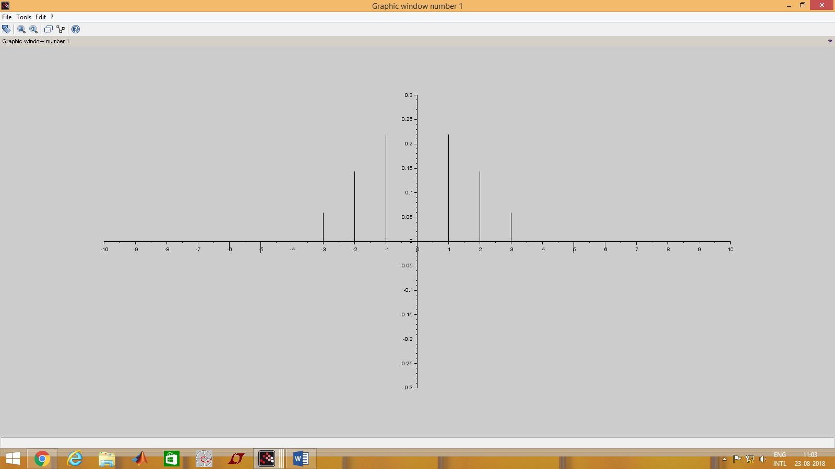

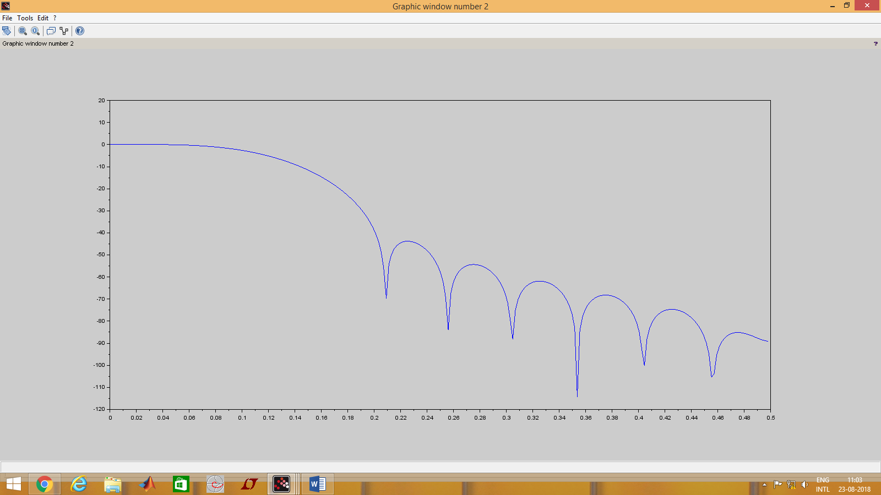

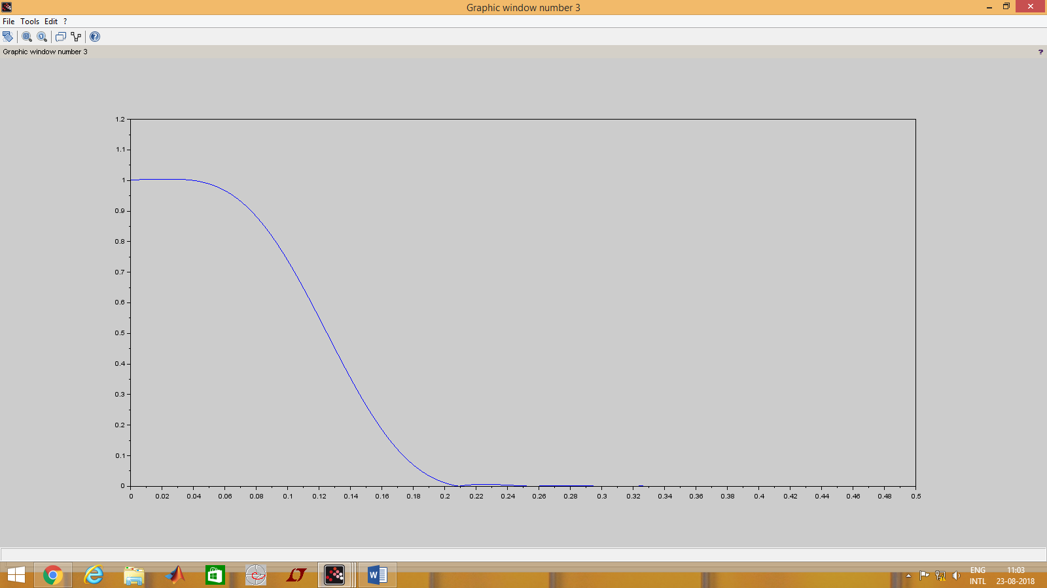

Rectangular window:

